A picture containing clipart

Description generated with very high confidence

ReactJS Module 2

Hands On - 7

[**support@intellipaat.com**](mailto:support@intellipaat.com)

**+91-7022374614**

**US: 1-800-216-8930(Toll Free)**

**ReactJS Module 2: Hands-on: 7**

**Creating functional components**

**Step 1:** Create a file named index.html in a folder with the following code.

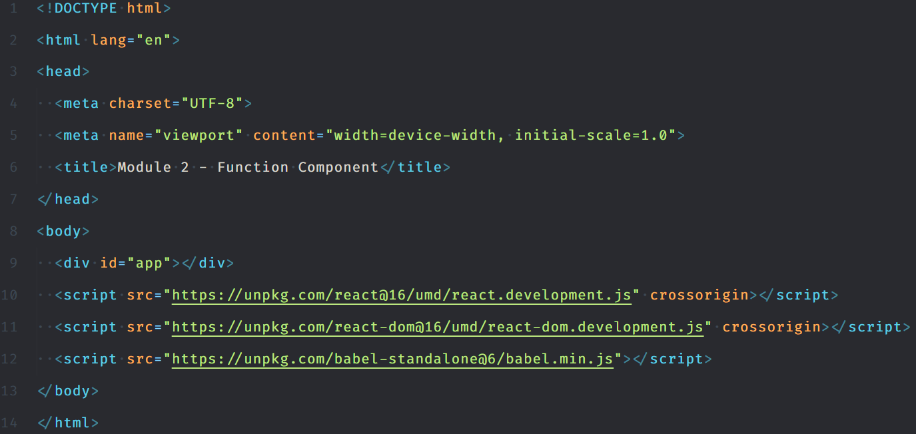

**Step 2:** Then add the following code within a script tag int the html body

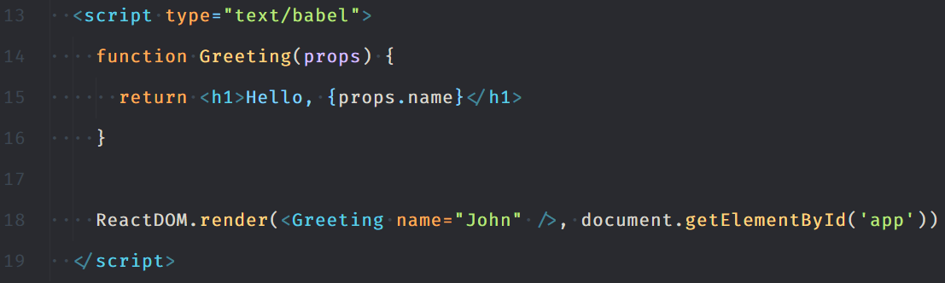

**Step 3:** Open index.html in a web browser and click on the button a few times.

